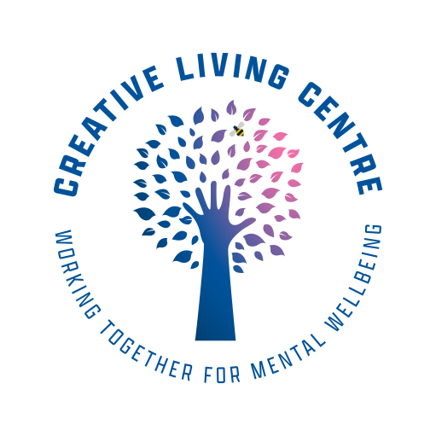
Policies and Procedures

04 Complaints Procedure

COMPLAINTS PROCEDURE
Introduction
The Creative Living Centre exists for its members. All the people who work at the Creative Living Centre including the volunteers are there to provide you with a service. If you are dissatisfied with the service you receive from any member of staff or volunteer, then you have the right to complain.

Staff at the centre are striving to make the service better and more responsible. They welcome any suggestions, comments or complaints about the service from you as a member. Please make your views known because your experience may not be an isolated incident but part of a bigger problem which the organisation needs to be aware of, if they are to do something about it.

Apart from perhaps gaining an apology and some satisfaction once you have raised your complaint, you may also improve the service to yourself and other members. We always aim to look at the whole picture of what went on, and how we can learn from this or do things differently if this is appropriate.

Please ask if you need help with any stage of this procedure. It is designed as a series of stages. If you are not satisfied with a decision at one stage, then you can take your complaint to the next.

At all stages the emphasis is on reaching agreement in a speedy and fair manner

Initial stage
All CLC staff are responsible for dealing with complaints at an early stage. If you have a grievance, talk to a member of staff. In most cases they will be able to solve the problem. You can have an advocate or friend to act as a representative at these discussions.

A member of staff or someone acting on behalf of the member should complete the relevant sections of the Incident / Complaint Report

Formal Procedure

Stage 1
If you are not happy with the response from the member of staff you can proceed to the formal complaint procedure. To do this, write to Service Delivery Manager & Chief Officer who will write to you within 7 working days to let you know that your complaint has been received. The written complaint should go to

Service Delivery Manager and Chief Officer
The Creative Living Centre
1a Rectory Lane
Prestwich
M25 1BP

The Service Delivery Manager will arrange to discuss the problem in detail with you. You can ask for a friend or advocate to act as your representative at these discussions.
Within 14 working days of the meeting, you will receive a written response to your complaint.

Stage 2
If you are not satisfied with the response you may go to the next stage of the formal procedure. The Appeal Process

How to appeal:
You may still not be happy with the response of the action taken to solve the problem. If so, you can appeal against the decision. To do this write to:

The Board of Trustees
The Creative Living Centre
1a Rectory Lane
Prestwich
M25 1BP

A sub committee will be formed and will acknowledge your letter within 7 working days. The sub committee will investigate the complaint and will send you a written response within 28 days to inform you of their decision. This decision will be final and there will be no further stage of appeal.

Date: 30/09/2022
Signed. JO JAMES

Print Name: JO JAMES
Co Chair (On behalf of the Board of Trustees)
Review Date: 1 September 2023

